## Reports/Inventory Reports/Comp Drug Pricing:

Request:

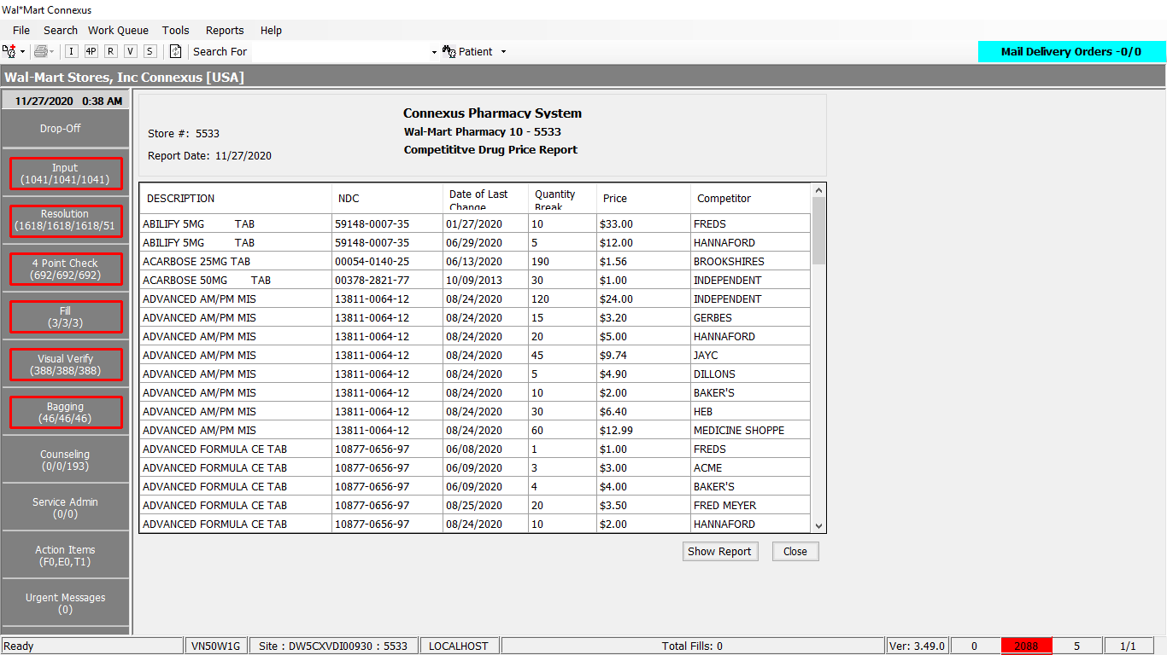

Response:

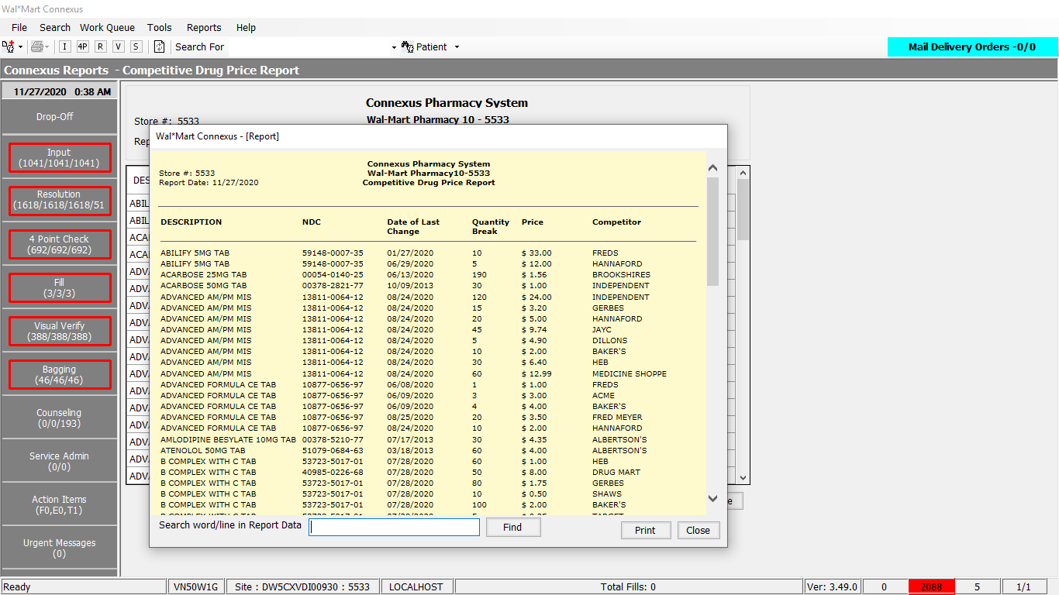

Queries:

Query is appended in the DAL method itself

DAL:

Public Function GetDrugCompPriceData(ByVal siteId As Integer,

ByVal sortOption As Integer) As _

List(Of GetDrugCompPriceDataInfoBE) Implements IReportDAL.GetDrugCompPriceData

Using (New Tracer(ConnexusCommonConstants.ConnexusTracer))

'Declare variables

Dim sqlString As New StringBuilder

Dim getDrufCompPriceDataInfoBEList As New List(Of GetDrugCompPriceDataInfoBE)

sqlString.Append("SELECT pi.ndc_nbr, pp.short_name, ")

sqlString.Append(" cpo.price_override_qty, cpo.price_override_amt, ")

sqlString.Append(" cpo.last_change_ts,pt.code_desc competitor")

sqlString.Append(" FROM pharmacy_offering:pharmacy_item pi, ")

sqlString.Append(" pharmacy_offering:pharmacy_product pp, ")

sqlString.Append(" pharmacy_offering:comp_price_overide cpo, ")

sqlString.Append(" pharmacy_code_txt pt ")

sqlString.Append(" WHERE pi.product_mds_fam_id = pp.product_mds_fam_id ")

sqlString.Append(" AND pi.mds_fam_id = cpo.mds_fam_id AND cpo.competition_code = pt.code_id")

If sortOption = 1 Then

sqlString.Append(" ORDER BY pp.short_name; ")

Else

sqlString.Append(" ORDER BY cpo.last_change_ts; ")

End If

Dim dataReader As IDataReader = ExecuteReader(DatabaseEnum.rx21c, siteId, sqlString.ToString)

Dim getDrugCompPriceDataBE As GetDrugCompPriceDataInfoBE

While dataReader.Read

getDrugCompPriceDataBE = New GetDrugCompPriceDataInfoBE

If Not dataReader.IsDBNull(dataReader.GetOrdinal("competitor")) Then

getDrugCompPriceDataBE.Competitor = CStr(dataReader("competitor")).Trim

End If

If Not dataReader.IsDBNull(dataReader.GetOrdinal("last_change_ts")) Then

getDrugCompPriceDataBE.LastChangeTs = CDate(dataReader("last_change_ts"))

End If

If Not dataReader.IsDBNull(dataReader.GetOrdinal("ndc_nbr")) Then

getDrugCompPriceDataBE.NdcNbr = CStr(dataReader("ndc_nbr"))

End If

If Not dataReader.IsDBNull(dataReader.GetOrdinal("price_override_amt")) Then

getDrugCompPriceDataBE.PriceOverrideAmt = CDec(dataReader("price_override_amt"))

End If

If Not dataReader.IsDBNull(dataReader.GetOrdinal("price_override_qty")) Then

getDrugCompPriceDataBE.PriceOverrideQty = CInt(dataReader("price_override_qty"))

End If

If Not dataReader.IsDBNull(dataReader.GetOrdinal("short_name")) Then

getDrugCompPriceDataBE.ShortName = CStr(dataReader("short_name")).Trim

End If

getDrufCompPriceDataInfoBEList.Add(getDrugCompPriceDataBE)

End While

If getDrufCompPriceDataInfoBEList.Count > 0 Then

Return getDrufCompPriceDataInfoBEList

Else

Return Nothing

End If

End Using

End Function